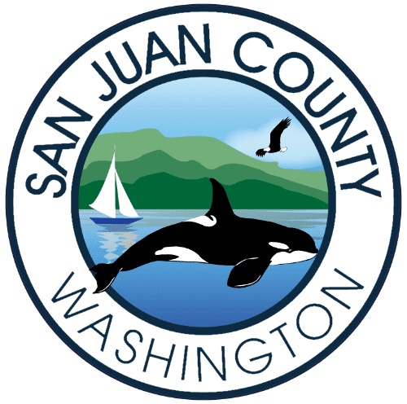

Charter Review Commission (CRC) SPECIAL Meeting Final Agenda
Wednesday, November 15, 2021, 4:00-6:00pm

Join Zoom Meeting
https://us02web.zoom.us/j/85271643269

Meeting ID: 852 7164 3269
One tap mobile
+12532158782,,85271643269# US (Tacoma)
+16699009128,,85271643269# US (San Jose)

Dial by your location
+1 253 215 8782 US (Tacoma)
+1 669 900 9128 US (San Jose)
+1 346 248 7799 US (Houston)
+1 312 626 6799 US (Chicago)
+1 646 558 8656 US (New York)
+1 301 715 8592 US (Washington DC)
Meeting ID: 852 7164 3269
Find your local number: https://us02web.zoom.us/u/kc3jo8TjR

- Members of the public, please turn off live video and mute yourself
- All, if you raise your hand (using ‘Reactions’), please lower your hand when you are finished speaking
- You may use ‘Chat’ to pass along information to others, as a group or individually

- Call to Order
- Roll Call
- Approve Minutes from October 13th and November 10th meetings
- Discuss & Action on Additional Propositions and / or Recommendations
- Public Comment 4:50pm
- Next steps / conclusion of Commission work
ADJOURNMENT

