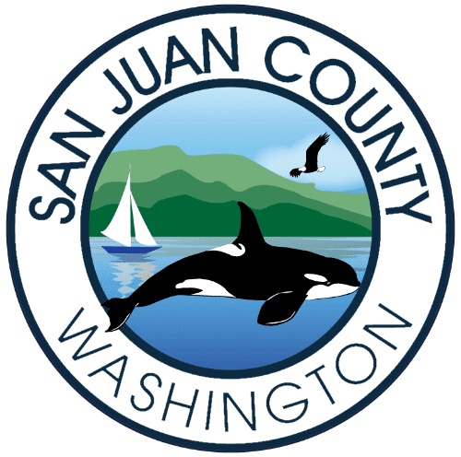

Charter Review Commission (CRC) Regular Meeting Agenda
June 30, 2021, 4:00pm-6:00pm (may end sooner)

Join Zoom Meeting
https://us02web.zoom.us/j/85271643269

Meeting ID: 852 7164 3269
One tap mobile
+12532158782,,85271643269# US (Tacoma)
+16699009128,,85271643269# US (San Jose)

Dial by your location
+1 253 215 8782 US (Tacoma)
+1 669 900 9128 US (San Jose)
+1 346 248 7799 US (Houston)
+1 312 626 6799 US (Chicago)
+1 646 558 8656 US (New York)
+1 301 715 8592 US (Washington DC)
Meeting ID: 852 7164 3269
Find your local number: https://us02web.zoom.us/u/kc3jo8TjR

- Members of the public, please turn off live video and mute yourself
- All, if you raise your hand (using ‘Reactions’), please lower your hand when you are finished speaking
- You may use ‘Chat’ to pass along information to others, as a group or individually

EXECUTIVE ACTION MAY BE TAKEN AT ANY REGULAR MEETING OF THE CHARTER REVIEW COMMISSION

- Call to Order
- Roll Call
- Approve Minutes from June 23 meeting
- Review proposed 2021 Amendments
  - Justice and Equity
    - Non-Discrimination statement
    - Justice, Equity & Inclusion Council
  - Initiatives & Referendums (3 sections)
  - Term Limits
  - Revised Introduction (3 parts)
  - Creation of the Climate & Environment Commissioner
- New Business
- Open for Public Comment (4:50pm)
ADJOURNMENT

