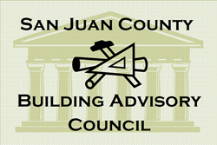
BUILDING ADVISORY COUNCIL
AGENDA
Thursday, May 30, 2019, 11:45 AM
Legislative Conference Room
San Juan Island

1:00 PM | CALL TO ORDER  ADMINISTRATIVE MATTERS  - Approval of Minutes from October 25, 2018
 | CITIZENS’ ACCESS TIME
 | CHAIR COMMENTS
 | COUNTY COUNCIL LIAISON COMMENTS
STAFF COMMENTS
- New Permitting Software – SmartGOV, Erika Shook, DCD Director
OLD BUSINESS
- Tiny Houses – new regulations, Richard Russell
NEW BUSINESS
- Building Official search
 | GENERAL COMENTS FROM BAC MEMBERS
 | ADJOURN
This agenda is subject to change. Discussion items may be added at the discretion of the Council Chair.

The next regularly scheduled meeting is Thursday, June 27, 2019 at 11:45 AM in the Legislative Conference Room, 55 second st, Friday Harbor.

